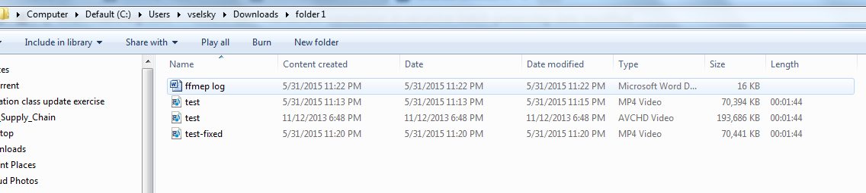

C:\Users\vselsky\Downloads>∩╗┐@echo off & setlocal
'∩╗┐@echo' is not recognized as an internal or external command,
operable program or batch file.

C:\Users\vselsky\Downloads>FOR /R %i in (*.mts) DO c:\ffmpeg\bin\ffmpeg -i "%~fi
" -i "%~dpni.mp4" -map 1 -map_metadata 0 -c copy "%~dpni-fixed.mp4"

C:\Users\vselsky\Downloads>c:\ffmpeg\bin\ffmpeg -i "C:\Users\vselsky\Downloads\f
older 1\test.MTS" -i "C:\Users\vselsky\Downloads\folder 1\test.mp4" -map 1 -map_
metadata 0 -c copy "C:\Users\vselsky\Downloads\folder 1\test-fixed.mp4"
ffmpeg version N-72336-ge48a9ac Copyright (c) 2000-2015 the FFmpeg developers
built with gcc 4.9.2 (GCC)
configuration: --enable-gpl --enable-version3 --disable-w32threads --enable-av
isynth --enable-bzlib --enable-fontconfig --enable-frei0r --enable-gnutls --enab
le-iconv --enable-libass --enable-libbluray --enable-libbs2b --enable-libcaca --
enable-libdcadec --enable-libfreetype --enable-libgme --enable-libgsm --enable-l
ibilbc --enable-libmodplug --enable-libmfx --enable-libmp3lame --enable-libopenc
ore-amrnb --enable-libopencore-amrwb --enable-libopenjpeg --enable-libopus --ena
ble-librtmp --enable-libschroedinger --enable-libsoxr --enable-libspeex --enable
-libtheora --enable-libtwolame --enable-libvidstab --enable-libvo-aacenc --enabl
e-libvo-amrwbenc --enable-libvorbis --enable-libvpx --enable-libwavpack --enable
-libwebp --enable-libx264 --enable-libx265 --enable-libxavs --enable-libxvid --e
nable-lzma --enable-decklink --enable-zlib
libavutil 54. 23.101 / 54. 23.101
libavcodec 56. 40.100 / 56. 40.100
libavformat 56. 33.101 / 56. 33.101
libavdevice 56. 4.100 / 56. 4.100
libavfilter 5. 16.101 / 5. 16.101
libswscale 3. 1.101 / 3. 1.101
libswresample 1. 1.100 / 1. 1.100
libpostproc 53. 3.100 / 53. 3.100
Input #0, mpegts, from 'C:\Users\vselsky\Downloads\folder 1\test.MTS':
Duration: 00:01:44.13, start: 0.888889, bitrate: 15237 kb/s
Program 1
Stream #0:0[0x1011]: Video: h264 (High) (HDMV / 0x564D4448), yuv420p(tv), 12
80x720 [SAR 1:1 DAR 16:9], 59.94 fps, 29.97 tbr, 90k tbn, 119.88 tbc
Stream #0:1[0x1100]: Audio: ac3 (AC-3 / 0x332D4341), 48000 Hz, stereo, fltp,
192 kb/s
Stream #0:2[0x1200]: Subtitle: hdmv_pgs_subtitle ([144][0][0][0] / 0x0090),
1280x720
Input #1, mov,mp4,m4a,3gp,3g2,mj2, from 'C:\Users\vselsky\Downloads\folder 1\tes
t.mp4':
Metadata:
major_brand : mp42
minor_version : 0
compatible_brands: mp42isomavc1
creation_time : 2015-06-01 03:13:32
encoder : HandBrake 0.9.9 2013052900
Duration: 00:01:44.15, start: 0.000000, bitrate: 5536 kb/s
Stream #1:0(und): Video: h264 (Main) (avc1 / 0x31637661), yuv420p(tv, bt709)
, 1280x720 [SAR 1:1 DAR 16:9], 5375 kb/s, 29.97 fps, 29.97 tbr, 90k tbn, 180k tb
c (default)
Metadata:
creation_time : 2015-06-01 03:13:32
encoder : JVT/AVC Coding
Stream #1:1(und): Audio: aac (LC) (mp4a / 0x6134706D), 48000 Hz, stereo, flt
p, 160 kb/s (default)
Metadata:
creation_time : 2015-06-01 03:13:32
[mp4 @ 0000000005f36f80] Codec for stream 0 does not use global headers but cont
ainer format requires global headers
[mp4 @ 0000000005f36f80] Codec for stream 1 does not use global headers but cont
ainer format requires global headers
Output #0, mp4, to 'C:\Users\vselsky\Downloads\folder 1\test-fixed.mp4':
Metadata:
encoder : Lavf56.33.101
Stream #0:0(und): Video: h264 ([33][0][0][0] / 0x0021), yuv420p, 1280x720 [S
AR 1:1 DAR 16:9], q=2-31, 5375 kb/s, 29.97 fps, 29.97 tbr, 90k tbn, 90k tbc (def
ault)
Metadata:
creation_time : 2015-06-01 03:13:32
encoder : JVT/AVC Coding
Stream #0:1(und): Audio: aac ([64][0][0][0] / 0x0040), 48000 Hz, stereo, 160
kb/s (default)
Metadata:
creation_time : 2015-06-01 03:13:32
Stream mapping:
Stream #1:0 -> #0:0 (copy)
Stream #1:1 -> #0:1 (copy)
Press [q] to stop, [?] for help
frame= 3119 fps=0.0 q=-1.0 Lsize= 70441kB time=00:01:44.14 bitrate=5540.6kbits
/s
video:68292kB audio:2035kB subtitle:0kB other streams:0kB global headers:0kB mux
ing overhead: 0.160666%

C:\Users\vselsky\Downloads>pause
Press any key to continue . . .

